Title of the Manuscript
(Provide a clear, concise, and informative title. Avoid abbreviations where possible.)
(Centralized; Bold; Times New Roman 14; Capitalize only the first letter of the first word and proper nouns)
Lily Oghenevovwero Otomewo¹, Olusegun Adebayo Adeoluwa¹*
(List all authors in order of contribution)
(Centralized; Times New Roman 12; First Name, Middle Name, Last Name; Affiliations indicated using superscript number after punctuation; Corresponding Author indicated using asterisk)

¹Department of Pharmacology and Therapeutics, College of Medicine and Health Sciences, Afe Babalola University, Ado-Ekiti, Ekiti State, Nigeria.
(Justified, Times New Roman 12; Department, Faculty, University/Institution, City, State, Country)

*Corresponding Author:
Name: Olusegun A. ADEOLUWA
Email: adeoluwaoa@abuad.edu.ng
Address: Department of Pharmacology and Therapeutics, College of Medicine and Health Sciences, Afe Babalola University, Ado-Ekiti, Ekiti State, Nigeria.
Phone: +2347000000000
ORCID ID: 0000-0000-0000-0000
(Justified; Times New Roman 12; Details must be written correctly)
(1.5-line spacing for the Title Page)

OTHER AUTHORS’ EMAIL ADDRESSES
Author 2: [email], ORCID [optional]
Author 3: [email], ORCID [optional]
Author 4: [email], ORCID [optional]
Abstract
(Structured Abstract: 250-300 words total.)
(Centralized; Bold; Times New Roman 14; single line spacing)
Background and Objectives: Briefly describe the scientific background and rationale of the study. State the objective or hypothesis tested. Materials and Methods: Summarize the design, experimental methods, and analytical approach. Results: State the key findings clearly and concisely. Conclusion: Summarize the principal findings and highlight implications.
(Structured; Justified; Times New Roman 12; Single line spacing; 300 words maximum)
Keywords: Technology, science, pharmacology
(List up to six (6) keywords separated by commas, no abbreviations. Each keyword must not appear within the manuscript title)

- Introduction (Section Heading in uppercase letters; bold; Times New Roman 14; left alignment)
Provide a concise overview of the research background, rationale, and objectives relevant to the study. Cite relevant literature appropriately. The introduction should not exceed one and a half (1½) pages.

(Section in Times New Roman 12; justified; single line spacing)

- Materials and Methods (Section Heading in uppercase letters and bold; Times New Roman 14; left alignment)
Describe the study design, materials, data collection procedures, and analysis methods. Ensure sufficient detail for reproducibility.

  - Experimental Animals and Ethical Approval (First level heading; Times New Roman 12; left alignment; Title Case, first letter of each word capitalized)
State species, strain, weight range, and source. Include ethical approval number.

2.1.1 Inclusion criteria (Second level heading; Times New Roman 12; left alignment; Sentence case, only first letter capitalized)
If available.

2.2 Chemicals and Reagents
List major chemicals, drugs, and reagents used, including manufacturer and source.
2.3 Experimental Design
Describe grouping, dosing regimen, and route of administration.
2.4 Behavioural and Biochemical Assays
Provide methods for each test, referencing standard protocols.
2.5 Statistical Analysis
Indicate statistical tests used, software version, and significance level (e.g., p < 0.05).

(Section information in Times New Roman 12; justified; single line spacing)

- Results (Section Heading in uppercase letters and bold; Times New Roman 14; left alignment)
Present key findings clearly, logically, and concisely, supported by tables, figures, and charts. Do not repeat all numerical data in the text.

(Tables and Figures)
Figures will appear individually on a single page and centralized. These should be numbered in Arabic numerals according to the sequence of appearance in the text, where they are referred to as Fig. 1, Fig. 2, etc.
Figure legends should be concise and clear and should not duplicate the body of the text. Each illustration must have a title and an explanatory legend. The title should be part of the legend and not be reproduced on the figure itself. The legends should be placed right below the illustration they refer to. All symbols and abbreviations used in the figure must be explained. Also, please mention each figure at the point of reference in the manuscript.
Tables should be so constructed that they, together with their captions and legends, will be intelligible with minimal reference to the text. Tables of numerical data should each be typed (with single-spacing) on a separate page, centralized, numbered in sequence in Arabic numerals (Table 1, 2, etc.) and referred to in the text as Table 1, Table 2, etc. The title of the table should appear above it. A detailed description of its contents should be given below the body of the table. Also, please mention each table at the point of reference in the manuscript.

Table 1: Example table title
(Table title at the top of the table in Sentence case; Times New Roman 11; centre alignment)
Group | Variable 1 | Variable 2
Control | 10.5±0.4 | 25.3±1.12
Treated | 8.7±0.6* | 18.9±0.8#
*represents…
#represents…
(Table legend should explain all symbols of significance within the table)
(Table centralized; Table contents in Times New Roman 11; centre alignment)

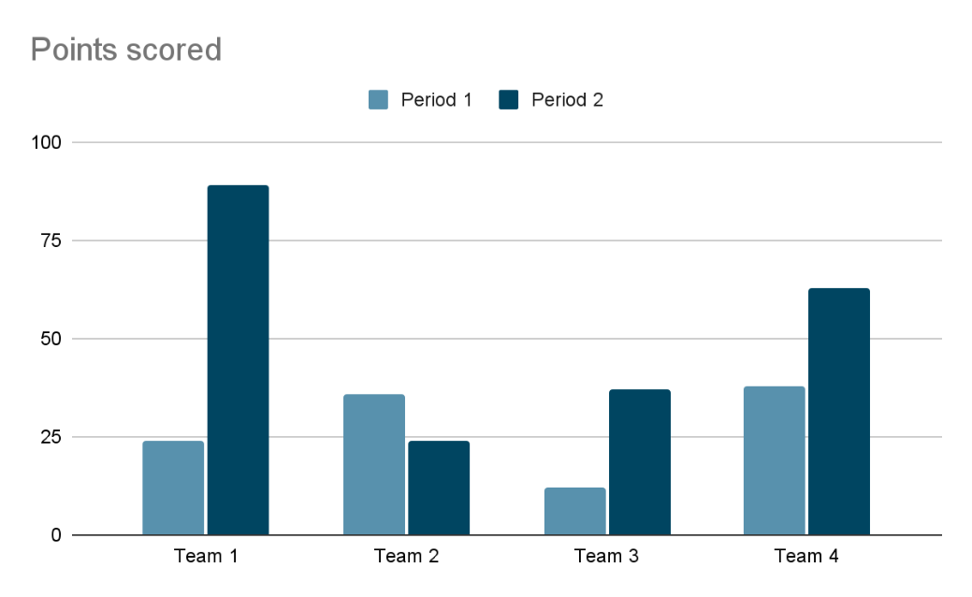
Fig. 1: Example figure title
(Figure centralized; Figure title under the figure in Sentence case; Times New Roman 11; centre alignment; key figure information must be embedded within the image)
Each bar represents mean ± SEM (n = 6).
*p < 0.05 compared with Team 1.
Team 1 represents the Pharmacology department.
Team 2 represents the Food Science department.
(Figure legends in Times New Roman 11; left alignment)
(Figure legend should explain all symbols of significance within the figure)

- Discussion (Section Heading in uppercase letters and bold; Times New Roman 14; left alignment)
Interpret the results in the context of existing literature. Explain how findings advance current knowledge and propose possible mechanisms or implications. Avoid repeating numerical data. Highlight limitations and future directions.
(Section in Times New Roman 12; justified; single line spacing)

- Conclusion (Section Heading in uppercase letters and bold; Times New Roman 14; left alignment)
Provide a concise summary of the main findings and their relevance. Avoid introducing new data or references.
(Section in Times New Roman 12; justified; single line spacing)

Acknowledgments (Section Heading in uppercase letters and bold; Times New Roman 14; left alignment)
(Optional) Recognize collaborators, or institutions that contributed to the study but did not meet authorship criteria.
(Section in Times New Roman 12; justified; single line spacing; write section in paragraphs)

Declarations
(Section Heading in uppercase letters and bold; Times New Roman 14; centre alignment)

Ethical approval (Level headings in sentence case; bold; Times New Roman 12; left alignment)
All experimental protocols were reviewed and approved by the Institutional Ethics Committee of [Institution Name] (Approval No: ...).

Conflict of interest
Declare any potential conflicts of interest or state: “None “if absent.

External funding
Declare any external funding support received or state: “None” if absent.

Consent to publish
In the case of human studies, state whether informed consent was obtained from the participants. If not required, state “Not applicable”

Author Contributions
(In this section, you must provide the contributor role of each author on these divisions: Conceptualization, Methodology, Software, Validation, Formal Analysis, Investigation, Resources, Data Curation, Writing – Original Draft Preparation, Writing – Review & Editing, Visualization, Supervision, Project Administration, Funding Acquisition)

(Section in Times New Roman 12; justified; single line spacing)

References (Centralized; Bold; Times New Roman 14; left alignment)
The authors are responsible for the accuracy of bibliographic information. Citations in the text should conform to the referencing style used by the last version of American Psychological Association (APA) style.

List all cited literature in alphabetical pattern using a hanging indentation style.

Examples of reference citations in text:

Single author:
(Adam, 1992) OR Adam (1992) proved that…

Two authors:
(Ringsven & Morse, 1996) OR In their study, Ringsven and Morse (1996)…

Three or more authors:
First citation: (Johnson, et al., 2002)
Subsequent citations: (Johnson et al., 2002)

In addition, all references cited in the text should be listed at the end of the manuscript on a separate page in alphabetical order by authors’ last names. All items in the list of references should be cited in the text and, conversely, all references cited in the text must be presented in the list using a hanging indentation style, listing all authors.

Reference to a journal publication:
Alabi, O. A., Adeoluwa, Y. M., & Bakare, A. A. (2020). Elevated Serum Pb, Ni, Cd, and Cr Levels and DNA Damage in Exfoliated Buccal Cells of Teenage Scavengers at a Major Electronic Waste Dumpsite in Lagos, Nigeria. Biological Trace Element Research, 194(1), 24–33. https://doi.org/10.1007/s12011-019-01745-z
Velmurugan, B. K., Rathinasamy, B., Lohanathan, B. P., Thiyagarajan, V., & Weng, C. F. (2018). Neuroprotective Role of Phytochemicals. Molecules (Basel, Switzerland), 23(10), 2485. https://doi.org/10.3390/molecules23102485

Reference to a book:

Flower, L., Hayes, J. R., Carey, L., Schriver, K., & Stratman, J. (1986). Detection, diagnosis, and strategies of revision. In L. Ede (Ed.), The Braddock essays (pp. 191-228). Boston: Bedford St. Martin's.
Frank, R. H., & Bernanke, B. (2007). Principles of macro-economics (3rd ed.). Boston: McGraw-Hill/Irwin.

